A MINI PROJECT REPORT

ON

“Video Calling Realtime Chat App & Social App”

Submitted in partial fulfillment of the requirements for
the award of the degree of

BACHELOR OF ENGINEERING IN COMPUTER ENGINNERING

Submitted by

1) Ojesh mundal - 01
2) Ganesh Hirve - 44
3) Rishabh Lokhande - 68
4) Shivansh Mishra - 77

Under the supervision of

Dr. Manjusha Deshmukh



Department OF Computer Engineering
Saraswati College of Engineering, Kharghar
(Affiliated to University of Mumbai)

(2025-26)


SARASWATI COLLEGE OF ENGINEERING

VISION

"To be globally recognized as an autonomous institute in engineering education with an emphasis on academics, research and skill enhancement to create innovators and future leaders for industry and societal needs.”

MISSION

- To provide theoretical and practical knowledge through quality teaching learning to develop competent engineers.

- To create an ambience that facilitates research, entrepreneurship and collaborations leading to emergence of innovators and future leaders.

- To develop a student-centric approach that inculcates moral, ethical values and leadership skills for holistic development.

Department OF Computer Engineering

VISION
“To become a globally competent graduate program and one of the leading institutions
in computer engineering education and research.”

MISSION

- To create distinguished engineering graduates by offering outstanding education, hands-on programming experience, and programming skills to meet the demands of the industry and society.

- To motivate students to engage in research, innovation, and entrepreneurship by encouraging them to learn new technologies and conduct research in computer engineering and other interdisciplinary fields.

- To provide an engaging learning environment that fosters creative thinking, problem-solving skills, leadership abilities, team-spirit, and ethical obligations.


DEPARTMENT OF COMPUTER ENGINEERING
Program Educational Objectives

- To establish a solid foundation in Computer Engineering principles, enabling professionals and entrepreneurs to identify, analyze, solve, and design real-world engineering solutions for the betterment of society.

- To promote and prepare students for research and lifetime learning in order to demonstrate their global competitiveness.

- To provide students the leadership, collaboration, and communication skills they need to take on challenges in every aspect of life in an ethical manner.



DEPARTMENT OF COMPUTER ENGINEERING
Programme Outcomes

PO 1: Engineering knowledge: Apply knowledge of mathematics, natural science, computing, engineering fundamentals and an engineering specialization as specified in WK1 to WK4 respectively to develop to the solution of complex engineering problems.
PO 2: Problem Analysis: Identify, formulate, review research literature and analyze complex engineering problems reaching substantiated conclusions with consideration for sustainable development. (WK1 to WK4)
PO 3: Design/Development of Solutions: Design creative solutions for complex engineering problems and design/develop systems/components/processes to meet identified needs with consideration for the public health and safety, whole-life cost, net zero carbon, culture, society and environment as required. (WK5)
PO 4: Conduct Investigations of Complex Problems: Conduct investigations of complex engineering problems using research-based knowledge including design of experiments, modelling, analysis & interpretation of data to provide valid conclusions. (WK8)
PO 5: Engineering Tool Usage: Create, select and apply appropriate techniques, resources and modern engineering & IT tools, including prediction and modelling recognizing their limitations to solve complex engineering problems. (WK2 and WK6)
PO 6: The Engineer and The World: Analyze and evaluate societal and environmental aspects while solving complex engineering problems for its impact on sustainability with reference to economy, health, safety, legal framework, culture and environment. (WK1, WK5, and WK7).
PO 7: Ethics: Apply ethical principles and commit to professional ethics, human values, diversity and inclusion; adhere to national & international laws. (WK9)
PO 8: Individual and Collaborative Team work: Function effectively as an individual, and as a member or leader in diverse/multi-disciplinary teams.(WK9)
PO 9: Communication: Communicate effectively and inclusively within the engineering community and society at large, such as being able to comprehend and write effective reports and design documentation, make effective presentations considering cultural, language, and learning differences
PO 10: Project Management and Finance: Apply knowledge and understanding of engineering management principles and economic decision-making and apply these to one’s own work, as a member and leader in a team, and to manage projects and in multidisciplinary environments.
PO 11: Life-Long Learning: Recognize the need for, and have the preparation and ability for i) independent and life-long learning ii) adaptability to new and emerging technologies and iii) critical thinking in the broadest context of technological change. (WK8)

Knowledge and Attitude Profile (WK)

WK1: A systematic, theory-based understanding of the natural sciences applicable to the discipline and awareness of relevant social sciences.
WK2: Conceptually-based mathematics, numerical analysis, data analysis, statistics and formal aspects of computer and information science to support detailed analysis and modelling applicable to the discipline.
WK3: A systematic, theory-based formulation of engineering fundamentals required in the engineering discipline.
WK4: Engineering specialist knowledge that provides theoretical frameworks and bodies of knowledge for the accepted practice areas in the engineering discipline; much is at the forefront of the discipline.
WK5: Knowledge, including efficient resource use, environmental impacts, whole-life cost, reuse of resources, net zero carbon, and similar concepts, that supports engineering design and operations in a practice area.
WK6: Knowledge of engineering practice (technology) in the practice areas in the engineering discipline.
WK7: Knowledge of the role of engineering in society and identified issues in engineering practice in the discipline, such as the professional responsibility of an engineer to public safety and sustainable development.
WK8: Engagement with selected knowledge in the current research literature of the discipline, awareness of the power of critical thinking and creative approaches to evaluate emerging issues.
WK9: Ethics, inclusive behavior and conduct. Knowledge of professional ethics, responsibilities, and norms of engineering practice. Awareness of the need for diversity by reason of ethnicity, gender, age, physical ability etc. with mutual understanding and respect, and of inclusive attitudes.



DEPARTMENT OF COMPUTER ENGINEERING
Programme Specific Outcomes

- Compute and evaluate intricate engineering problems in computer engineering such as cloud computing, real-time systems, networking, big data, intelligent systems, etc.

- Plan and create dependable, secure, and cost-effective system and application software with developing software tools that are morally affordable.

A MINI PROJECT REPORT

ON

“Video Calling Realtime Chat App & Social App”

Submitted in partial fulfillment of the requirements for
the award of the degree of

BACHELOR OF ENGINEERING IN COMPUTER NGINNERING

Submitted by

1) Ojesh mundal - 01
2) Ganesh Hirve - 44
3) Rishabh Lokhande - 68
4) Shivansh Mishra - 77

Under the supervision of

Dr. Manjusha Deshmukh


Department OF Computer Engineering
Saraswati College of Engineering, Kharghar
(Affiliated to University of Mumbai)

(2025-26)


CERTIFICATE

This is to certify that the requirements for the mini project report entitled” Video Calling Realtime Chat App & Social App” have been successfully completed by the following students:

Roll numbers Name
01 Ojesh mundal
44 Ganesh Hirve
68 Rishabh Lokhande
77 Shivansh Mishra

In partial fulfillment of v, Bachelor of Engineering of Mumbai University in Computer Engineering of Saraswati college of Engineering, Kharghar during the academic year 2025-26.

Supervisor/Guide
Dr. Manjusha Deshmukh

Head of Department Principal
Prof. Sujata Bhairnallyka Dr. Manjusha Deshmukh

Project Report Approval Sheet

This project report entitled Video Calling Realtime Chat App & Social App by

1) Ojesh mundal - 01
2) Ganesh Hirve - 44
3) Rishabh Lokhande - 68
4) Shivansh Mishra - 77

is approved for the partial fulfillment of Computer Engineering.

Examiners

1.

2.

Date:

Place:

Declaration

We declare that this written submission represents our ideas in our own words and where others' ideas or words have been included, we have adequately cited and referenced the original sources. We also declare that We have adhered to all principles of academic honesty and integrity and have not misrepresented, fabricated or falsified any idea/data/fact/source in our submission. We understand that any violation of the above will be cause for disciplinary action by the Institute and can also evoke penal action from the sources which have thus not been properly cited or from whom proper permission has not been taken when needed.

1) Ojesh mundal - 01
2) Ganesh Hirve - 44
3) Rishabh Lokhande - 68
4) Shivansh Mishra - 77

Date:

Abstract

The project demonstrates the end-to-end development of a production-ready full-stack chat application with advanced real-time features. It integrates secure authentication using JWT, user onboarding, and friend management with a backend built on Node.js, Express, and MongoDB, following modular route and controller design. Real-time chat and video calling, including reactions, threads, screen sharing, and call recording, are implemented using the Stream platform, ensuring scalability. On the frontend, React with React Query, Axios, and React Router manages state, data fetching, and navigation, while Tailwind CSS and Daisy UI deliver a modern, customizable UI supporting 32 dynamic themes through Zustand. Deployment is achieved on Render.com, serving both backend and frontend under a single domain with environment configuration. The project emphasizes clean architecture, modularity, and best practices, showcasing a scalable solution for real-time communication platforms.

Table Of Contents:

1 Introduction…………………………...…....….…..(i)
2 Methodology…………………………..……….…..(ii)
3 Hardware software requirement………….……..….(iii)
4 Design details……………………………….…..…(iv)
5 Implementation and Result………………………...(v)
6 Conclusion………………………………….…...…(vi)
7 Future Scope………………………………..….…..(vii)
8 References………………………………..………..(viii)
9 Acknowledgments………………………………….(ix)

Chapter 1

Introduction
In today’s digital world, real-time communication platforms have become a core necessity for personal, educational, and professional interaction. Traditional chat applications often provide only basic text messaging, but modern users demand advanced features such as seamless video calling, group interactions, real-time presence indicators, multimedia sharing, and secure authentication. To address these needs, this project focuses on building a production-ready full-stack chat application that combines messaging, video calls, and social connectivity with a scalable and secure architecture.
The application is designed as part of a language exchange platform, where users can interact across cultures while benefiting from smooth communication features. The project integrates one-on-one and group chats, typing indicators, reactions, message threads, image uploads, and video calls with advanced capabilities like screen sharing, in-call reactions, and call recording. A friend system allows users to send and accept friend requests, view recommended users, and maintain an active social circle within the app.
On the backend, the system is powered by Node.js, Express, and MongoDB, providing a robust and modular API structure. Security is ensured through JWT-based authentication, HTTP-only cookies, and middleware-protected routes. The user model includes onboarding details, friends list management, and profile customization, while passwords are securely hashed with bcrypt. The backend also integrates with the Stream API, which handles real-time chat and video call infrastructure, ensuring scalability and reliability.
The frontend leverages React with React Router for smooth navigation, React Query for efficient server-state management, and Axios for API communication. UI is built with Tailwind CSS and Daisy UI, providing a modern, responsive design enhanced with 32 dynamic themes managed by Zustand and persisted in localStorage. Toast notifications, avatars, and user-friendly layouts enrich the overall user experience.
Deployment is carried out on Render.com, where both frontend and backend are served under a single domain. Environment variables and build scripts are used to ensure seamless deployment. This makes the app ready for real-world usage and allows it to be included in a professional portfolio or resume.
This project highlights not only the technical depth of full-stack development but also emphasizes best practices in architecture, modularity, scalability, and user experience design, ultimately delivering a communication platform that balances functionality, performance, and usability..

Chapter 2

Literature Review

Real-time communication systems have evolved significantly over the past decade, moving from simple text-based messaging platforms to feature-rich applications integrating multimedia and video communication. Research in this domain emphasizes the importance of scalability, low latency, security, and user experience. Traditional messaging systems often rely on polling mechanisms, which are inefficient and resource-intensive. Modern systems use WebSocket-based architectures or real-time APIs, such as Stream, to maintain persistent connections for instantaneous message delivery and updates.
Several studies highlight the role of secure authentication and authorization mechanisms in chat applications. JWT (JSON Web Tokens) has emerged as a standard for securing user sessions, allowing stateless authentication and easy integration with middleware for route protection. Hashing algorithms such as bcrypt are widely recommended for securely storing user passwords, ensuring that sensitive information remains protected even if the database is compromised.
Database design plays a crucial role in chat systems. NoSQL databases like MongoDB are preferred for handling large volumes of user-generated content due to their flexibility in schema design, scalability, and support for embedded documents. The use of Mongoose as an Object Data Modeling (ODM) tool simplifies schema validation, middleware implementation, and database interactions in Node.js environments.
On the frontend, frameworks like React enable the creation of single-page applications (SPAs) that provide dynamic user experiences. State management and data fetching have been significantly improved through tools such as React Query (TanStack Query), which handle caching, background updates, and server-state synchronization efficiently. UI libraries such as Tailwind CSS and Daisy UI have been widely adopted to streamline responsive design and component-based styling, reducing development time and improving consistency.
Real-time chat and video functionalities have been extensively studied in both academic and industry contexts. APIs like Stream and Twilio abstract the complexities of low-level WebRTC implementation, enabling developers to integrate video calls, screen sharing, reactions, and threaded messaging efficiently. These platforms provide built-in scalability, security, and reliability, which are critical for production-ready applications.
Overall, the literature demonstrates that developing a modern chat application requires a careful combination of secure authentication, real-time communication protocols, scalable backend architecture, and user-friendly frontend design. Integrating these technologies with best practices in modularity, state management, and deployment ensures that applications are robust, maintainable, and ready for production use.

Chapter 3

Aim and Objectives
Aim

To develop a production-ready full-stack chat application that provides secure, real-time messaging and video calling features, along with a scalable architecture, user-friendly interface, and social interaction capabilities suitable for a language exchange platform.

Objectives

Design a secure backend architecture using Node.js, Express, and MongoDB with JWT-based authentication and route protection.
Implement a robust user model including onboarding status, profile customization, friend management, and password hashing with bcrypt.Integrate real-time chat and video calls using the Stream API, supporting features such as typing indicators, reactions, threads, screen sharing, and call recording.
Develop a dynamic frontend using React, React Router, React Query, Axios, Tailwind CSS, and Daisy UI, ensuring smooth navigation, responsive design, and interactive UI elements.
Provide global theme customization with multiple UI themes managed via Zustand and persisted in localStorage.
Ensure secure and efficient data fetching using React Query and Axios with error handling, caching, and authentication checks.
Implement friend request management including sending, accepting, and listing friends with real-time UI updates.
Deploy the application under a single domain using Render.com, ensuring that both backend and frontend are accessible in production.
Demonstrate scalability and maintainability by following modular coding practices, separating routes, controllers, and custom hooks, and using middleware for authentication and onboarding checks.

Methodology

The methodology of this project outlines the systematic approach used to design, develop, and deploy a production-ready full-stack chat application with real-time messaging and video calling functionalities. The development process is divided into backend development, frontend development, integration, testing, and deployment, ensuring modularity, scalability, and maintainability.

1. Requirement Analysis
- Identified functional requirements such as user authentication, friend management, real-time chat, video calling, onboarding, and notifications.
- Determined non-functional requirements including security, scalability, responsiveness, and theme customization.
- Selected suitable technologies based on requirements: Node.js, Express, MongoDB for backend; React, Tailwind CSS, Daisy UI, React Query, Axios for frontend; Stream API for real-time chat and video infrastructure.

2. Backend Development
- Initialized backend with Node.js and Express, creating a modular folder structure separating routes, controllers, and middleware.
- Implemented JWT-based authentication with HTTP-only cookies for secure login sessions.
- Designed user model with Mongoose including fields for profile information, onboarding status, friends list, and hashed passwords using bcrypt.
- Developed RESTful API endpoints for signup, login, logout, onboarding, friend requests, notifications, and chat token generation.
- Integrated Stream API for real-time chat and video call authentication, supporting one-on-one and group communications.

3. Frontend Development
- Set up React project with Vite and structured pages for Home, Signup, Login, Onboarding, Notifications, Chat, and Call.
- Integrated Tailwind CSS and Daisy UI for responsive and dynamic UI components.
- Implemented React Router for single-page application routing and navigation guards to protect routes based on authentication and onboarding status.
- Configured React Query and Axios for efficient server-state management, data fetching, mutations, and caching.
- Built custom React hooks (useSignup, useLogin, useAuthUser) for reusable authentication logic.
- Enabled 32 dynamic themes with Zustand state management and persisted selection in localStorage.

4. Integration
- Connected frontend and backend via Axios with credentials for secure cookie handling.
- Ensured real-time synchronization for chat messages, friend requests, and notifications using Stream SDK and React Query refetch/invalidation mechanisms.
- Implemented video calling using Stream Video React SDK, including features like multi-user calls, screen sharing, reactions, and call recording.

5. Testing
- Tested backend APIs using Postman for functionality, validation, and error handling.
- Performed frontend functional testing to ensure correct routing, UI updates, data fetching, and responsive design.
- Verified real-time chat and video call interactions, including edge cases like duplicate friend requests and unauthorized access.
- Debugged issues related to database operations, JWT token handling, and Stream API integration.

6. Deployment
- Configured Render.com for deployment, serving both frontend and backend under the same domain.
- Created build scripts to automate frontend compilation and backend server start-up.
- Configured environment variables for API keys, JWT secrets, and dynamic ports.
- Verified full application functionality in production, including authentication, chat, video calls, onboarding, and theme management.

7. Documentation & Maintenance
- Documented folder structure, API endpoints, and frontend component hierarchy.
- Ensured modularity in code for maintainability and future scalability.
- Provided guidelines for updating themes, adding new features, or scaling the application.

Chapter 5

Implementation And Result

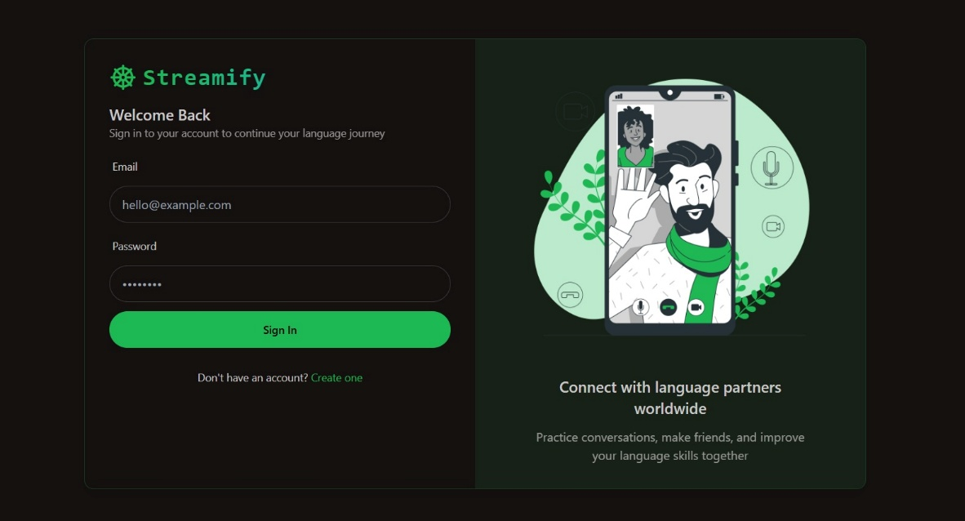

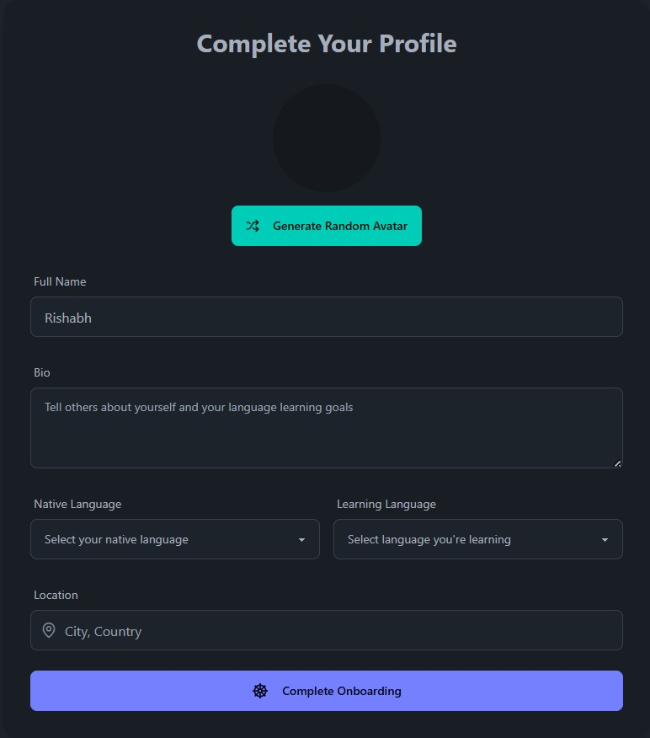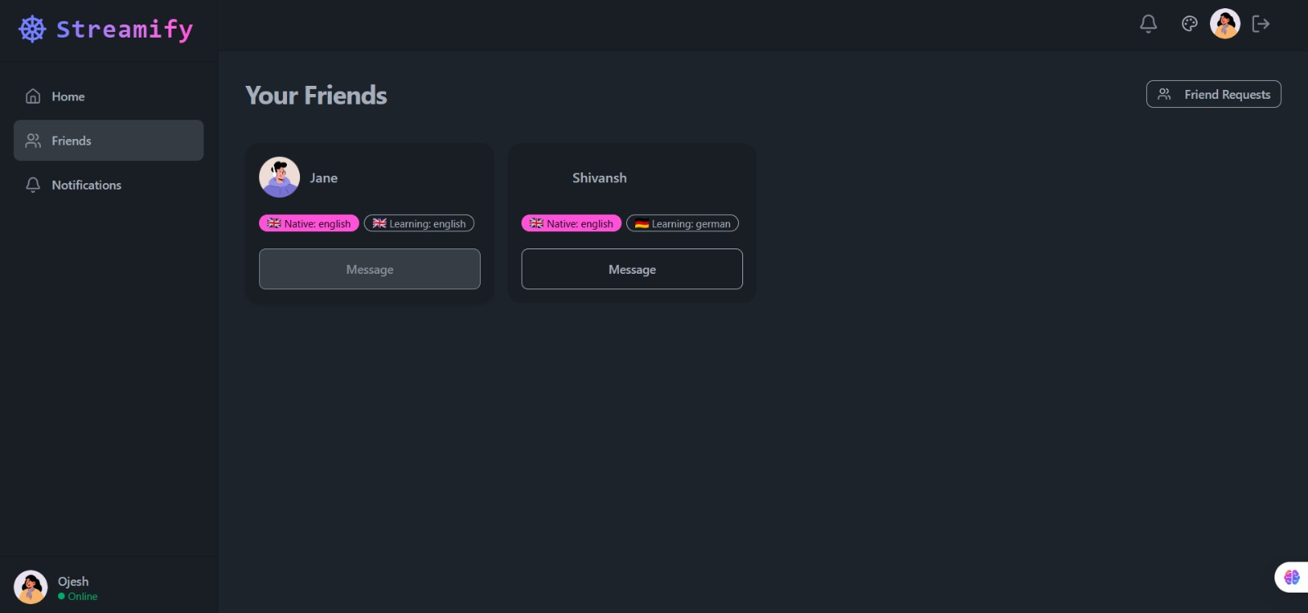

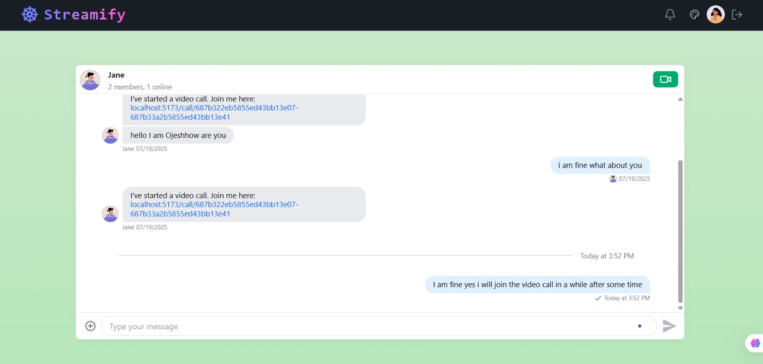

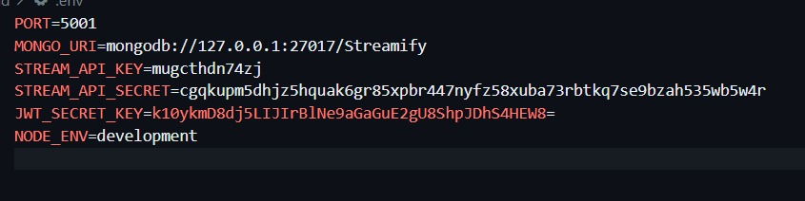

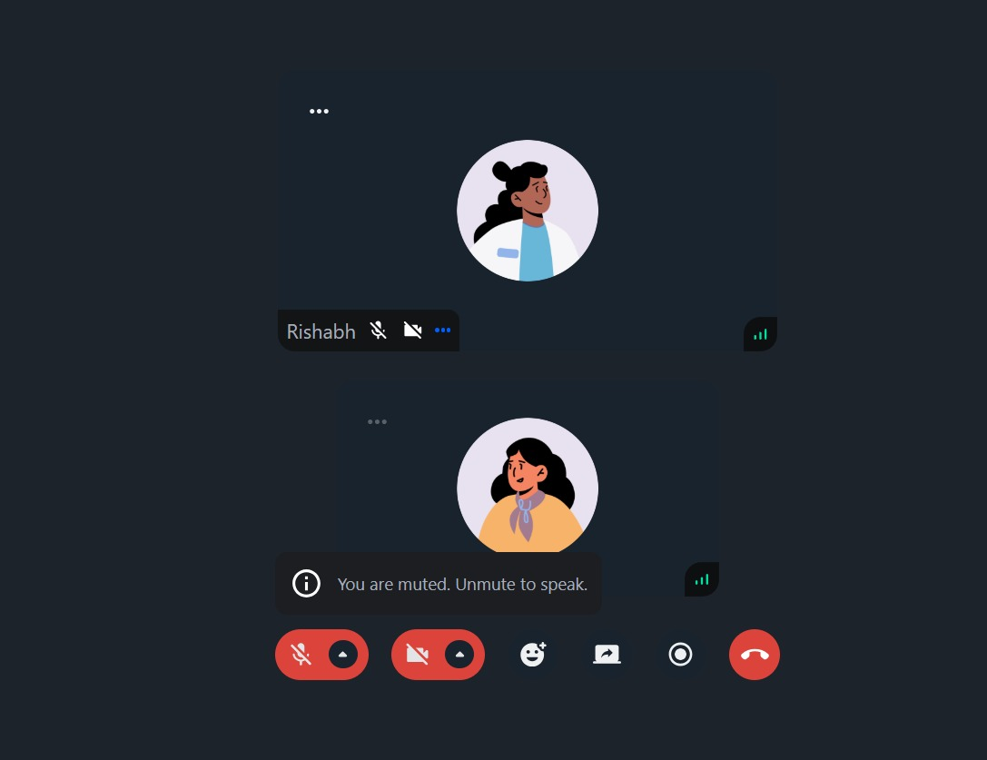

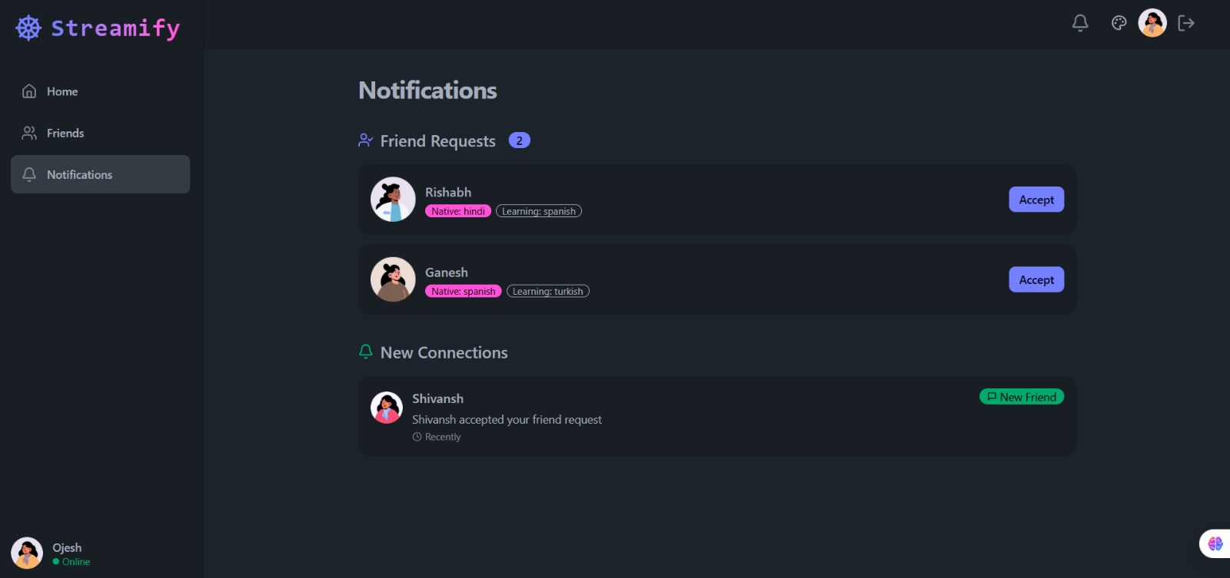

Chapter 6

Conclusion Scope of Future Study

The project successfully demonstrates the development of a production-ready full-stack chat application that integrates real-time messaging, video calling, and social interaction features. By leveraging Node.js, Express, and MongoDB on the backend, the application provides a secure and scalable environment for user authentication, onboarding, and friend management. JWT-based authentication and bcrypt password hashing ensure secure user sessions and data protection.
On the frontend, React combined with React Query, Axios, Tailwind CSS, and Daisy UI delivers a responsive and dynamic user interface. Integration with Stream API enables real-time chat and video call functionality, including one-on-one and group calls, reactions, threads, screen sharing, and call recording. The implementation of 32 dynamic themes with Zustand ensures a customizable user experience.
Deployment on Render.com demonstrates the application’s readiness for production, with both backend and frontend served under a single domain. The project successfully illustrates best practices in full-stack development, modularity, maintainability, and real-time communication integration, making it suitable for use in educational, social, and collaborative environments.

Scope for Future Study

The project provides a strong foundation for future enhancements and research in the domain of real-time communication platforms. Potential areas for further development include:
Enhanced Multimedia Support: Integration of file sharing (documents, audio) and message search functionality for more comprehensive communication.
Advanced Video Call Features: Adding breakout rooms, virtual backgrounds, AI-driven noise suppression, and live transcription.
Push Notifications & Offline Messaging: Implementing browser and mobile push notifications, along with offline message storage and synchronization.
AI Integration: Using AI-powered chatbots for language learning, moderation, or personalized recommendations.
Performance Optimization: Scaling the backend using microservices architecture, load balancing, and horizontal scaling for larger user bases.
Analytics & Insights: Adding dashboards for user activity, engagement, and communication patterns for data-driven improvements.
Cross-Platform Mobile Application: Developing Android and iOS apps using React Native or Flutter to extend accessibility.
Enhanced Security: Incorporating multi-factor authentication (MFA), end-to-end encryption for messages, and GDPR-compliant user data handling.
Overall, the project lays a strong foundation for building next-generation real-time communication systems, combining functionality, security, scalability, and user-friendly design.

